Johnson Solid
# Source: AI Source: Provided by: [Data Path: Persons Table -> ID Column: 1, Name_En Column: Motasem Essam] -> From: [ChatGPT] on [7/25/2026]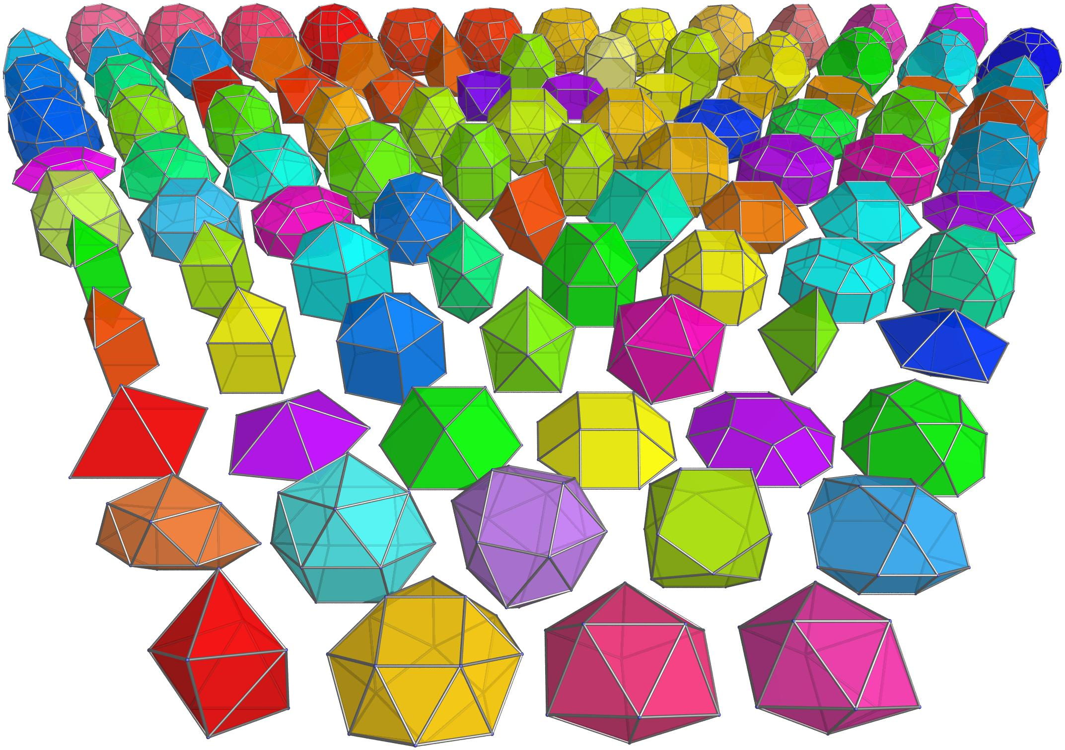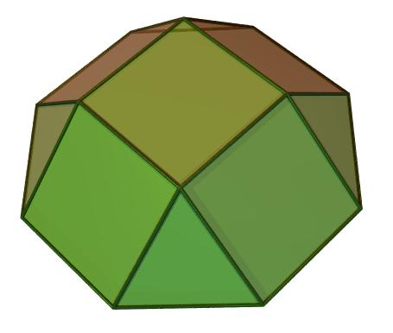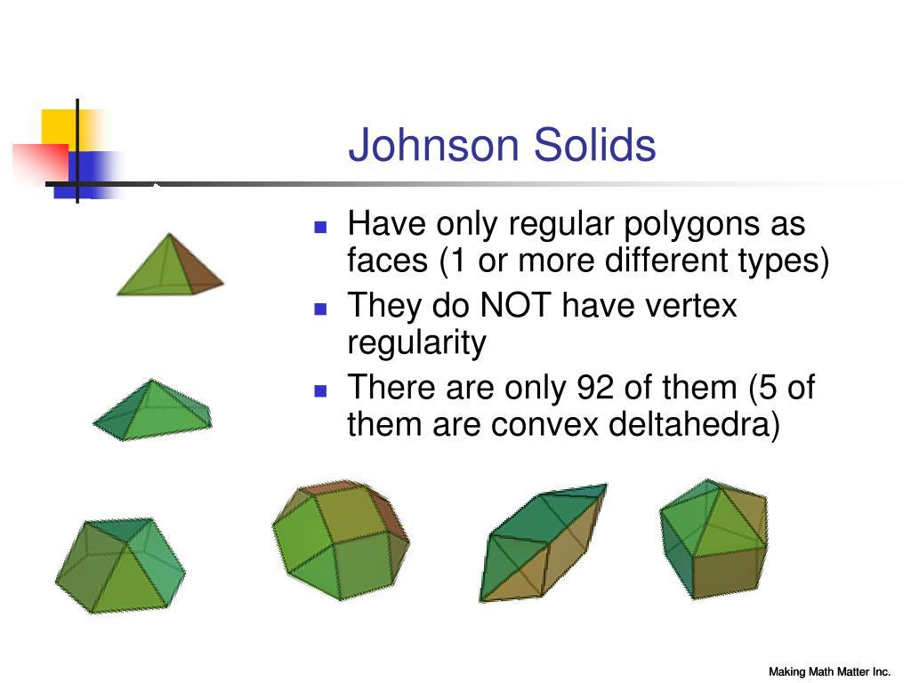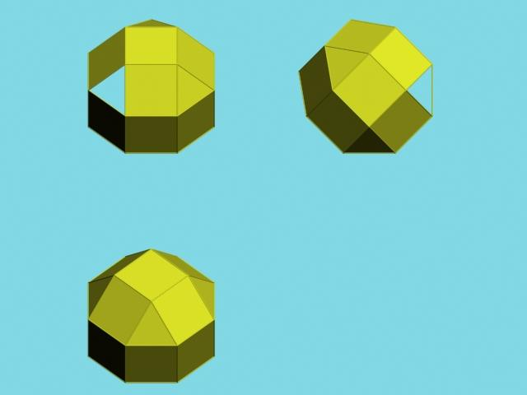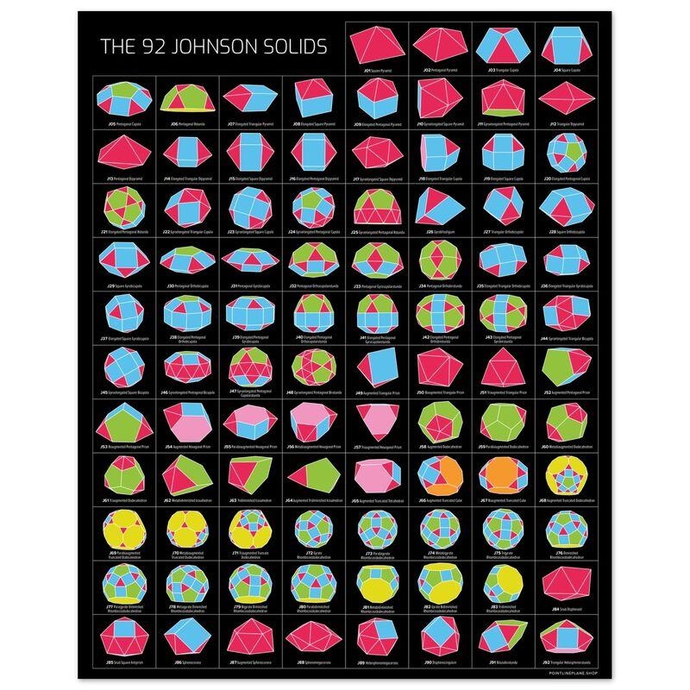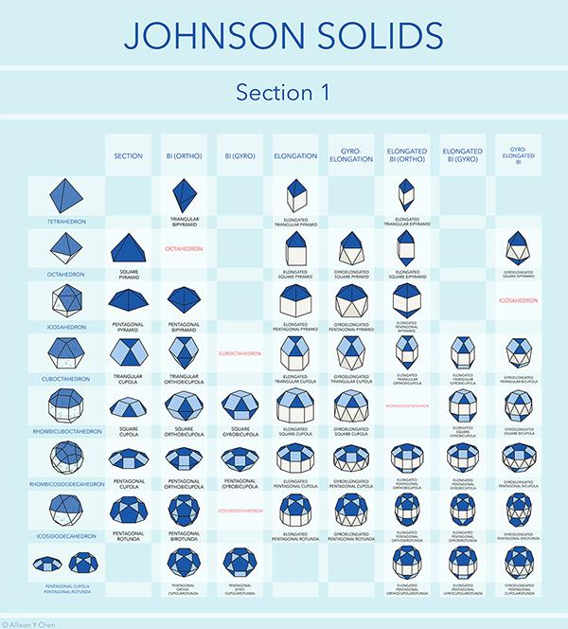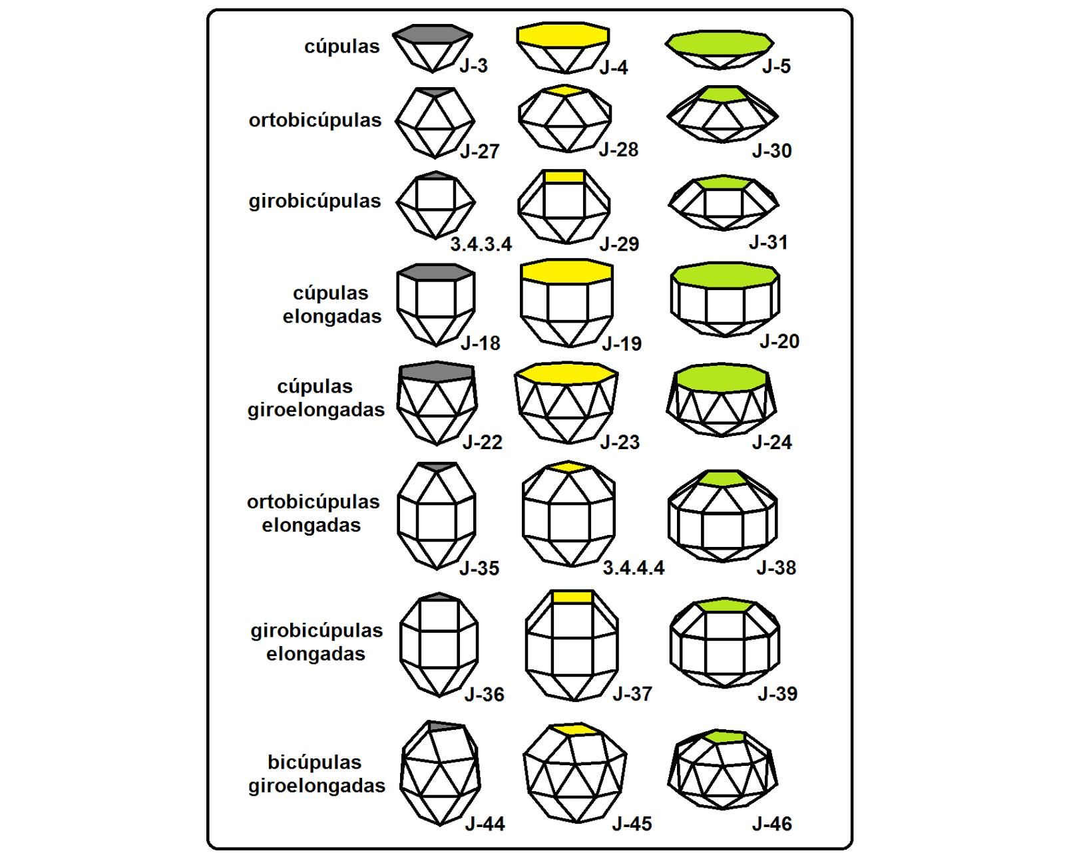

Definition
# Source: AI Source: Provided by: [Data Path: Persons Table -> ID Column: 1, Name_En Column: Motasem Essam] -> From: [ChatGPT] on [7/25/2026]
A Johnson Solid is a strictly convex three-dimensional polyhedron whose faces are all regular polygons, with all edges having equal lengths.
Johnson solids are distinguished from the Platonic solids, Archimedean solids, regular prisms, and regular antiprisms.
There are exactly 92 Johnson solids, numbered from J1 to J92. They were catalogued by mathematician Norman W. Johnson in 1966, and their completeness was proved by Victor Zalgaller in 1969.

Geometric Structure
# Source: AI Source: Provided by: [Data Path: Persons Table -> ID Column: 1, Name_En Column: Motasem Essam] -> From: [ChatGPT] on [7/25/2026]
A Johnson solid has these general characteristics:
- Faces: Every face is a regular polygon, such as an equilateral triangle, square, regular pentagon, or regular hexagon.
- Edges: All edges have the same length.
- Vertices: Three or more faces meet at each vertex.
- Convexity: The solid is strictly convex, with no inward dents.
- Face Arrangement: The arrangement of faces around vertices does not need to be identical throughout the solid.

Main Characteristics
# Source: AI Source: Provided by: [Data Path: Persons Table -> ID Column: 1, Name_En Column: Motasem Essam] -> From: [ChatGPT] on [7/25/2026]
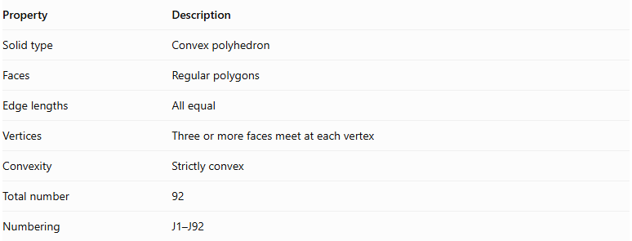
Property | Description
Solid type | Convex polyhedron
Faces | Regular polygons
Edge lengths | All equal
Vertices | Three or more faces meet at each vertex
Convexity | Strictly convex
Total number | 92
Numbering | J1–J92
Euler's Formula:
Every Johnson solid satisfies Euler's polyhedron formula:
$$V-E+F=2$$
Where:
- $V$ = Number of vertices.
- $E$ = Number of edges.
- $F$ = Number of faces.

Types of Johnson Solids
# Source: AI Source: Provided by: [Data Path: Persons Table -> ID Column: 1, Name_En Column: Motasem Essam] -> From: [ChatGPT] on [7/25/2026]
The 92 Johnson solids can be organized into several structural groups:
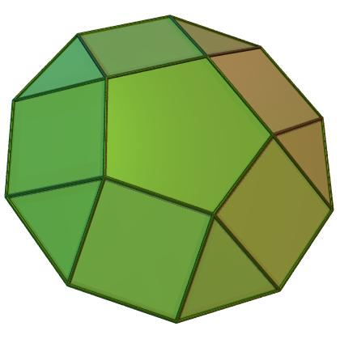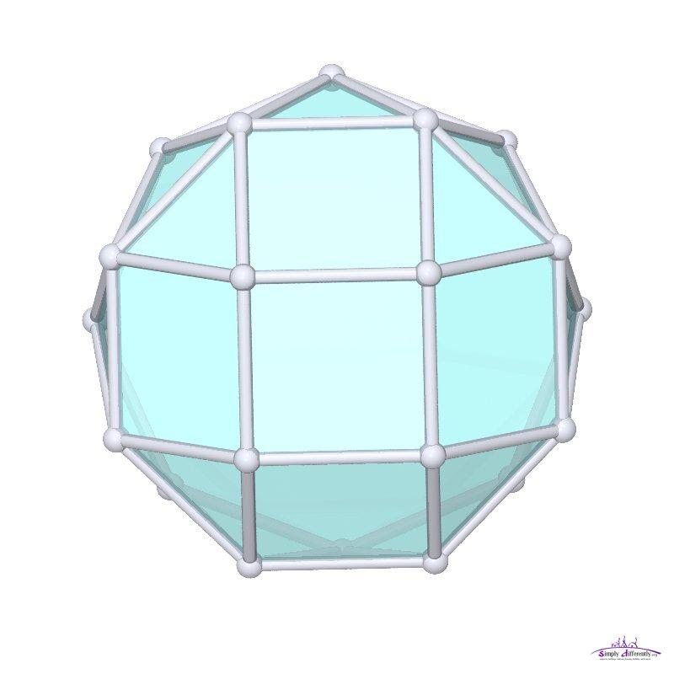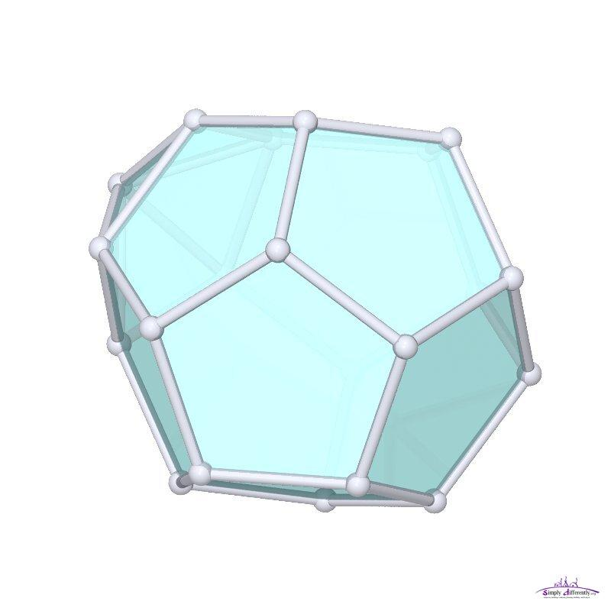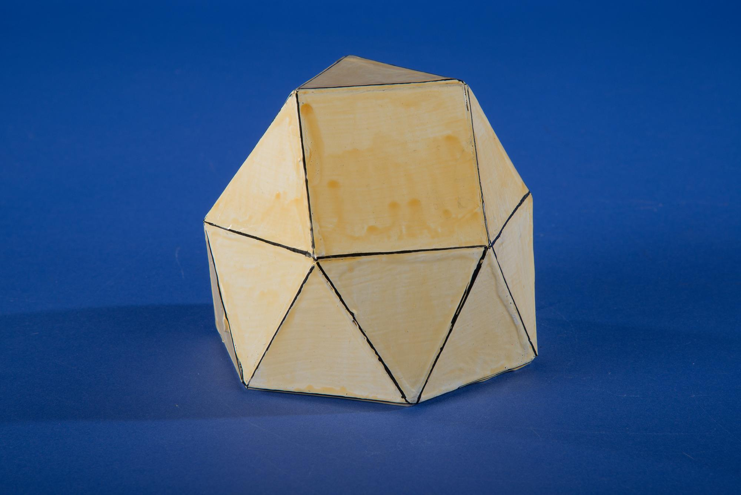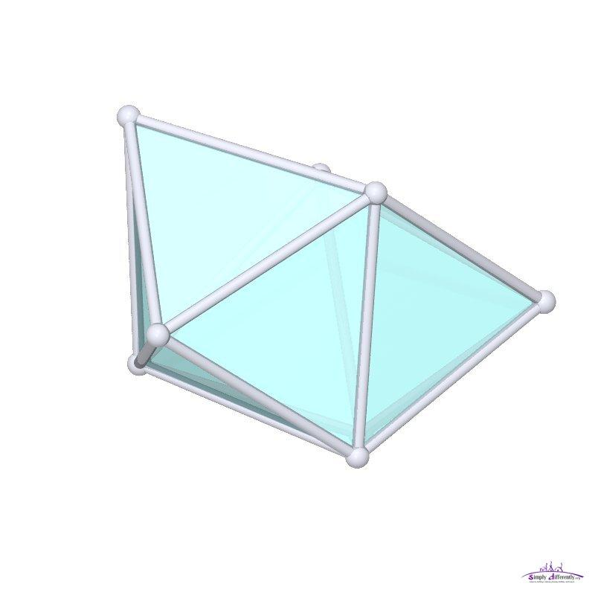
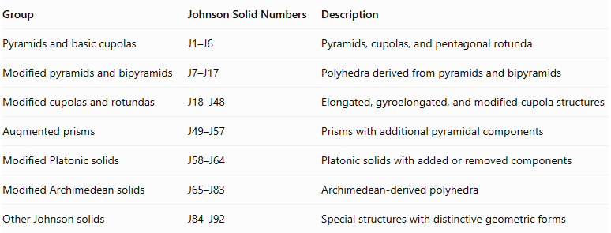
Group | Johnson Solid Numbers | Description
Pyramids and basic cupolas | J1–J6 | Pyramids, cupolas, and pentagonal rotunda
Modified pyramids and bipyramids | J7–J17 | Polyhedra derived from pyramids and bipyramids
Modified cupolas and rotundas | J18–J48 | Elongated, gyroelongated, and modified cupola structures
Augmented prisms | J49–J57 | Prisms with additional pyramidal components
Modified Platonic solids | J58–J64 | Platonic solids with added or removed components
Modified Archimedean solids | J65–J83 | Archimedean-derived polyhedra
Other Johnson solids | J84–J92 | Special structures with distinctive geometric forms
This is a structural grouping of the numbered list, rather than a separate mathematical classification. <Cite refs={["turn882348search0","turn882348search6"]}/>

Examples of Johnson Solids
# Source: AI Source: Provided by: [Data Path: Persons Table -> ID Column: 1, Name_En Column: Motasem Essam] -> From: [ChatGPT] on [7/25/2026]
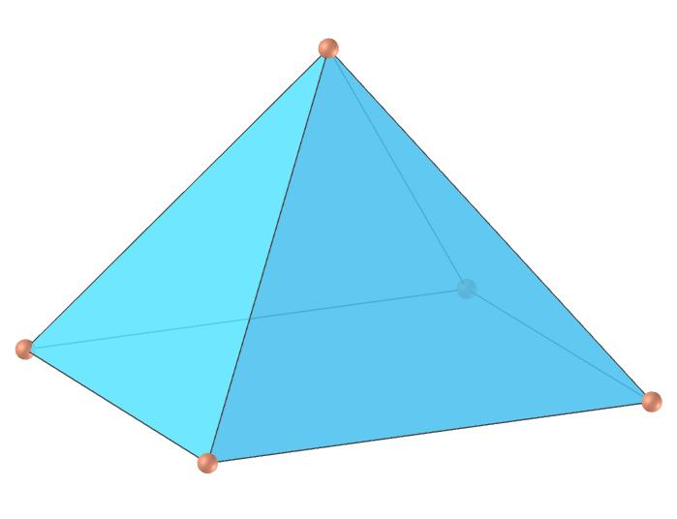

Square Pyramid (J1)
# Source: AI Source: Provided by: [Data Path: Persons Table -> ID Column: 1, Name_En Column: Motasem Essam] -> From: [ChatGPT] on [7/25/2026]
- 1 square face.
- 4 equilateral triangular faces.
- 5 faces, 8 edges, 5 vertices.
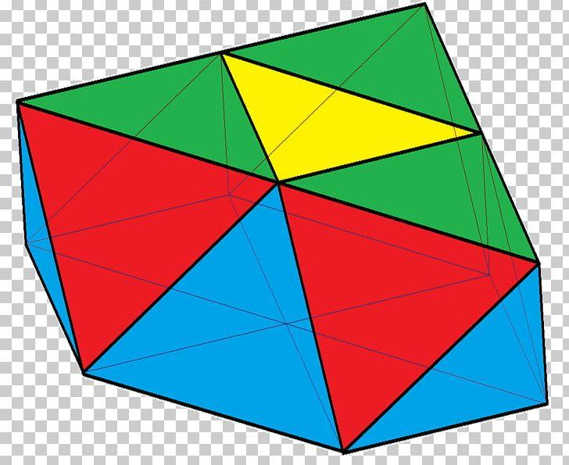

Triangular Cupola (J3)
# Source: AI Source: Provided by: [Data Path: Persons Table -> ID Column: 1, Name_En Column: Motasem Essam] -> From: [ChatGPT] on [7/25/2026]
- 1 triangle and 1 hexagon.
- 3 squares and 4 triangles laterally.
- 8 faces, 15 edges, 9 vertices.
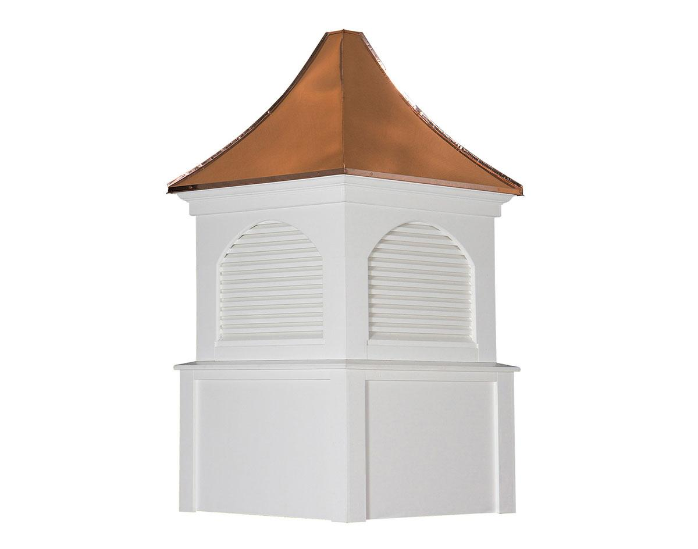

Square Cupola (J4)
# Source: AI Source: Provided by: [Data Path: Persons Table -> ID Column: 1, Name_En Column: Motasem Essam] -> From: [ChatGPT] on [7/25/2026]
- 1 square and 1 octagon.
- 4 squares and 4 triangles laterally.
- 10 faces, 20 edges, 12 vertices.

Pentagonal Cupola (J5)
# Source: AI Source: Provided by: [Data Path: Persons Table -> ID Column: 1, Name_En Column: Motasem Essam] -> From: [ChatGPT] on [7/25/2026]
- 1 pentagon and 1 decagon.
- 5 squares and 5 triangles laterally.
- 12 faces, 25 edges, 15 vertices.
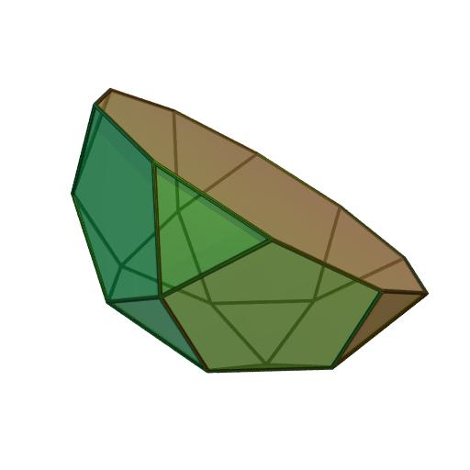

Pentagonal Rotunda (J6)
# Source: AI Source: Provided by: [Data Path: Persons Table -> ID Column: 1, Name_En Column: Motasem Essam] -> From: [ChatGPT] on [7/25/2026]
- A pentagonal upper region and a decagonal lower base.
- Contains pentagonal, triangular, and other regular polygonal faces.
- 17 faces, 25 edges, 10 vertices.

Important Geometric Rules
# Source: AI Source: Provided by: [Data Path: Persons Table -> ID Column: 1, Name_En Column: Motasem Essam] -> From: [ChatGPT] on [7/25/2026]
- Every face must be a regular polygon.
- Every edge must have the same length.
- The solid must be strictly convex.
- The arrangement of faces around vertices does not have to be identical.
- A polyhedron is not automatically a Johnson solid just because all its faces are regular; it must also meet the classification requirements.
Important distinction for your Cupola classification: The Square Cupola (J4) and Pentagonal Cupola (J5) are Johnson solids. A generalized Hexagonal Cupola is not one of the 92 standard Johnson solids. <Cite refs={["turn882348search0","turn882348search2"]}/>

Classification
# Source: AI Source: Provided by: [Data Path: Persons Table -> ID Column: 1, Name_En Column: Motasem Essam] -> From: [ChatGPT] on [7/25/2026]
Solid Geometry
└── Types of Solids
└── Johnson Solids
├── Pyramids and Basic Cupolas
├── Modified Pyramids and Bipyramids
├── Modified Cupolas and Rotundas
├── Augmented Prisms
├── Modified Platonic Solids
├── Modified Archimedean Solids
└── Other Johnson Solids

Conclusion
# Source: AI Source: Provided by: [Data Path: Persons Table -> ID Column: 1, Name_En Column: Motasem Essam] -> From: [ChatGPT] on [7/25/2026]
A Johnson Solid is one of 92 strictly convex polyhedra with regular polygonal faces and equal edge lengths. The family includes pyramids, cupolas, rotundas, augmented solids, and several distinctive polyhedral structures.
References:
- <Link ref="turn882348search0" title="Wolfram MathWorld – Johnson Solid"/>
- <Link ref="turn882348search8" title="George Hart – Johnson Solids"/>
- <Link ref="turn882348search2" title="Johnson Solids – Mathematical Description"/>

